Takween Connect 2nd Draft Review– By Rabia Hafeez
Key visual issues and fixes
1. Hero section
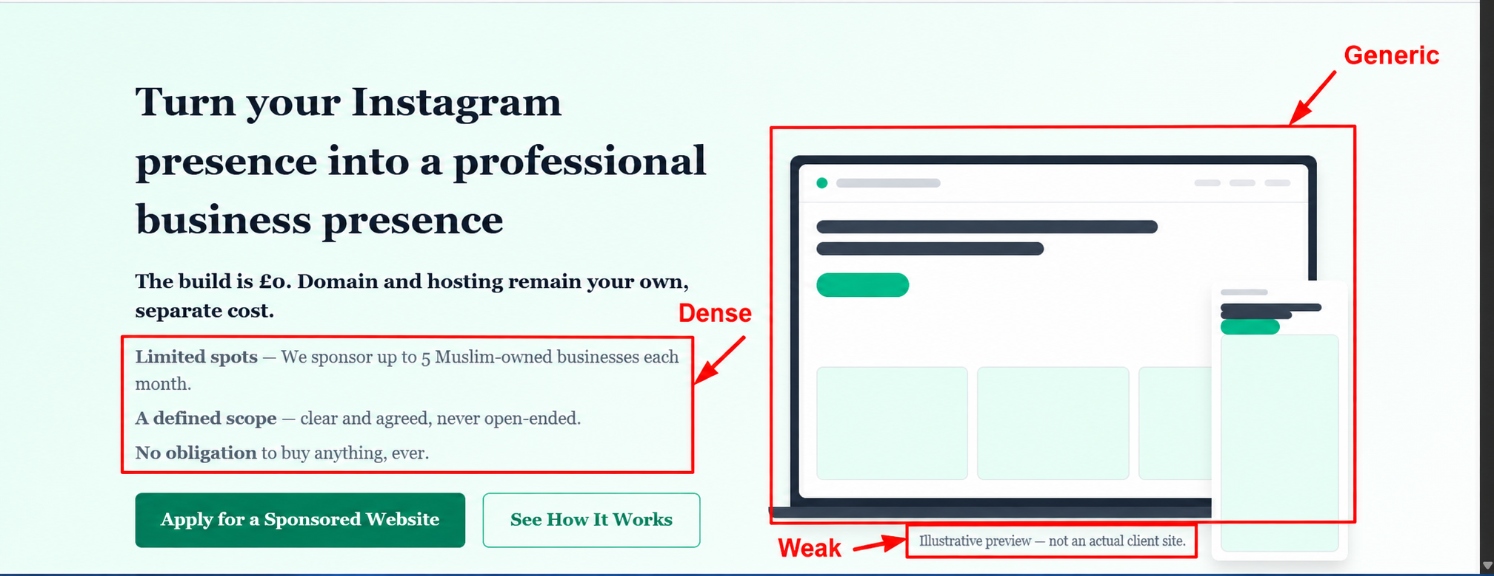
Issue: The hero uses a generic illustration and the supporting copy feels dense.
Fix: Replace the illustration with a real Takween portfolio website mockup (laptop + mobile) and tighten the supporting points.
2. Offer summary strip
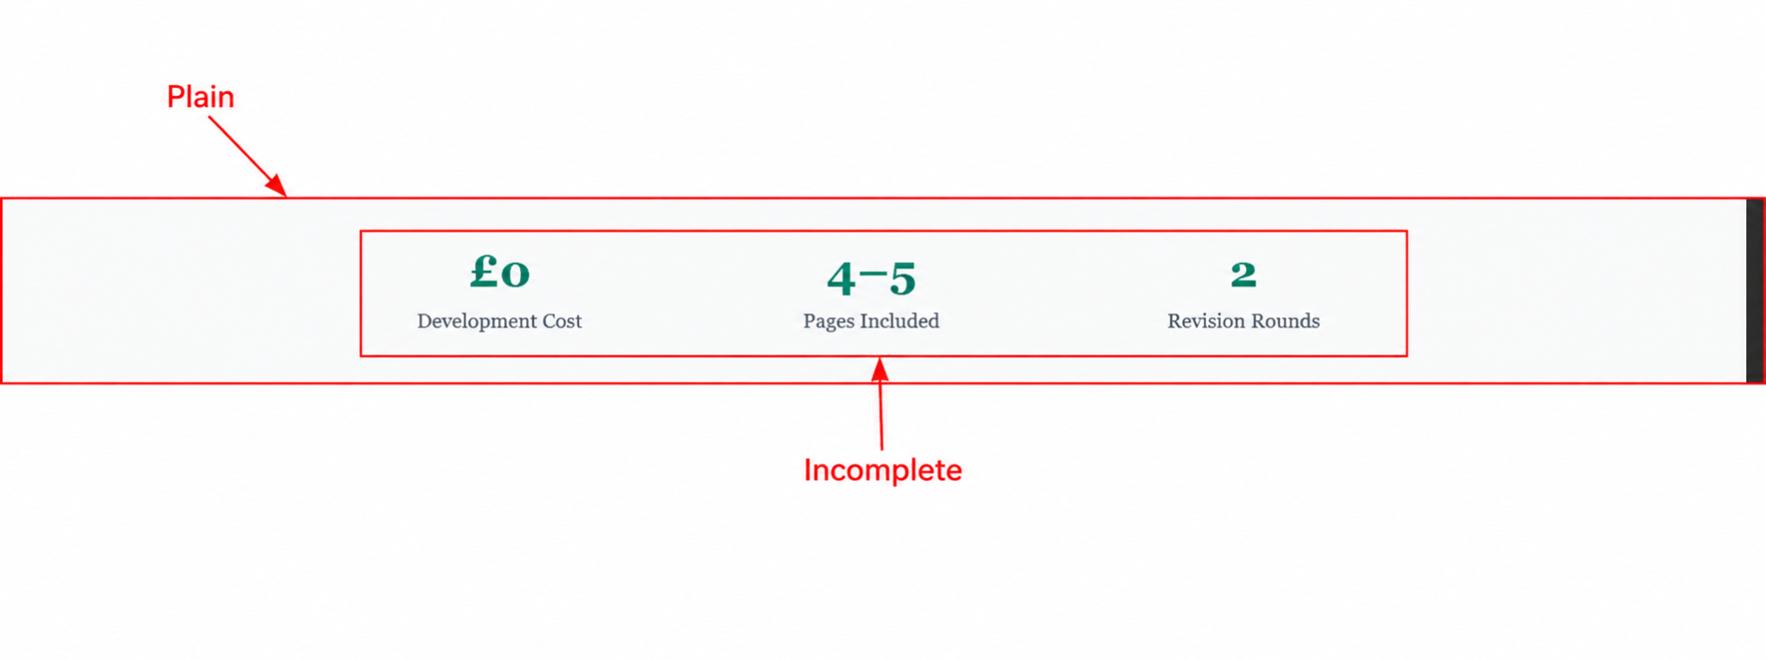
Issue: The £0 / 4–5 pages / 2 revisions strip looks too plain and unfinished.
Fix: Give each metric stronger visual treatment, such as small consistent icons, clearer separation, or compact stat cards.
Takween Connect – Landing Page Review
3. Who It's For
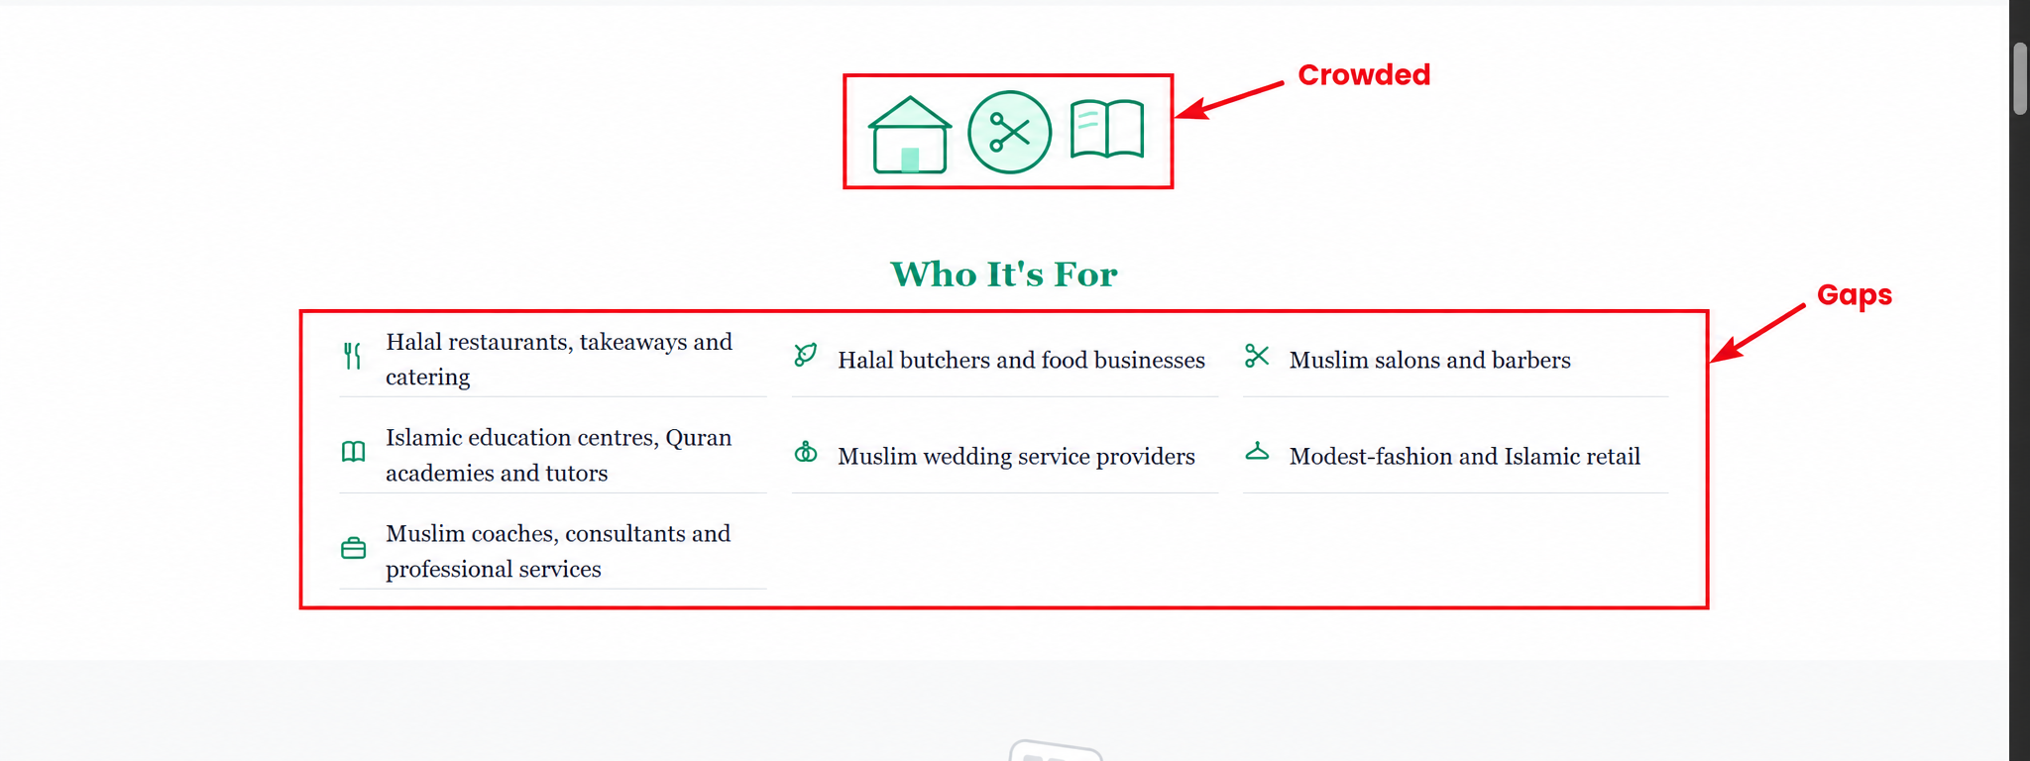
Issue: The three top icons are crowded, and the three content columns have insufficient spacing.
Fix: Use one strong section icon (or increase spacing) and add clear horizontal gaps between the three columns.
4. What the Website Solves
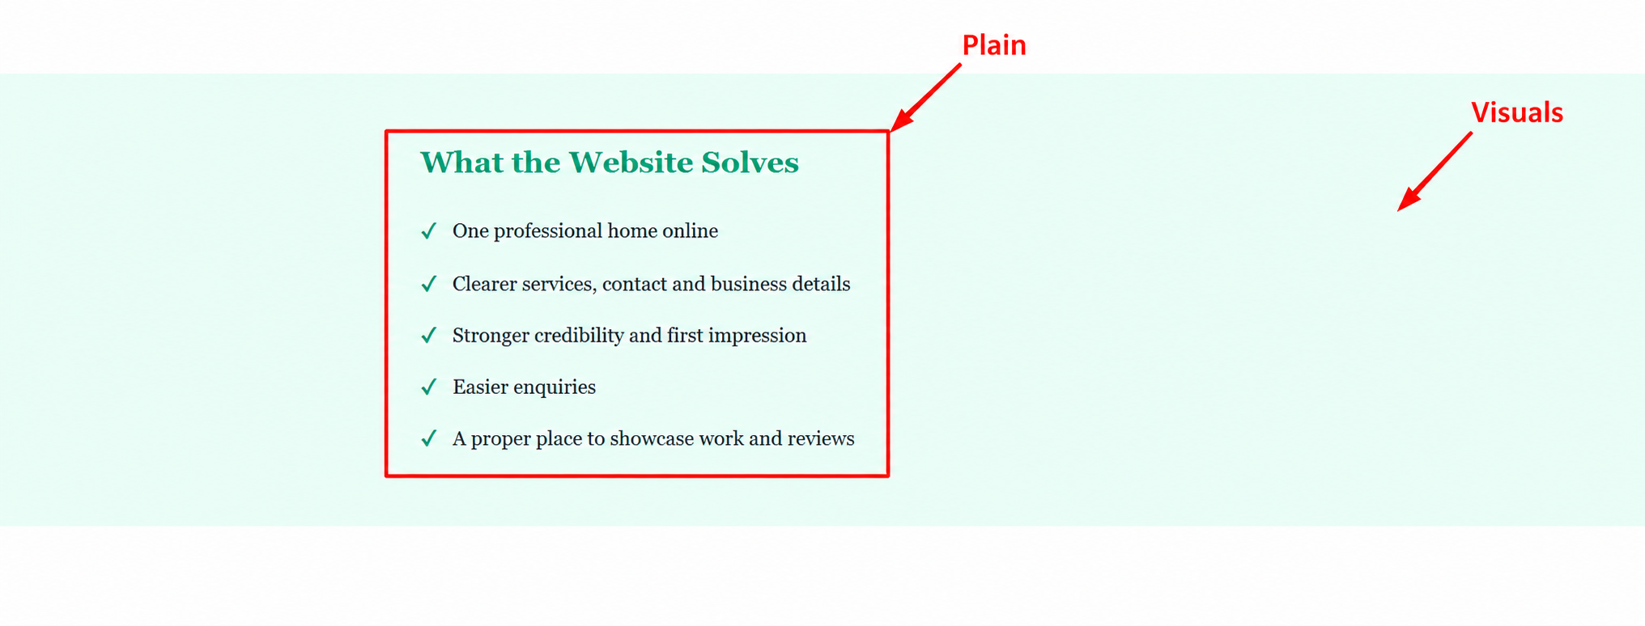
Issue: The section relies almost entirely on text and feels visually empty.
Fix: Add a relevant illustration or a consistent icon for each key outcome, while keeping the copy short.
Takween Connect – Landing Page Review
5. Why It's Sponsored
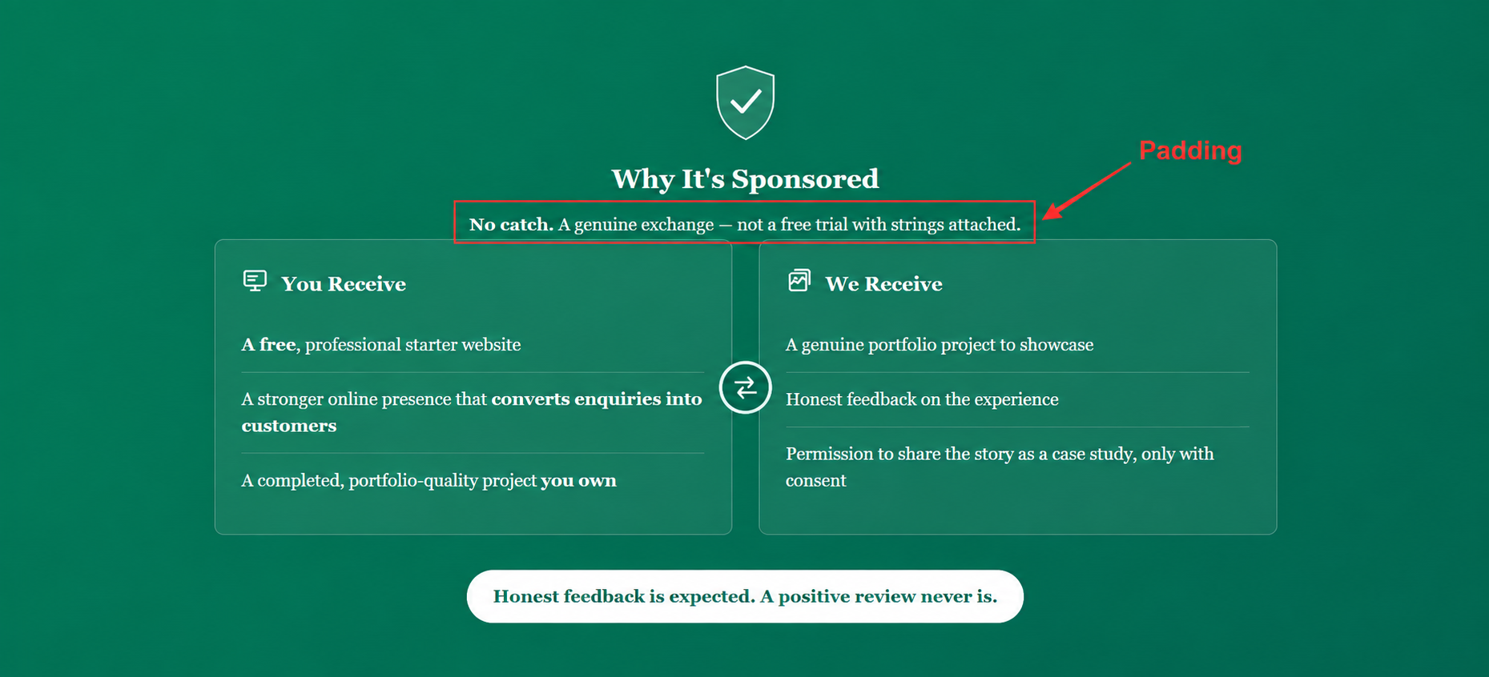
Issue: The supporting line sits too close to the comparison cards below.
Fix: Increase the bottom margin/padding below the supporting line to create clearer separation.
6. What's In Scope
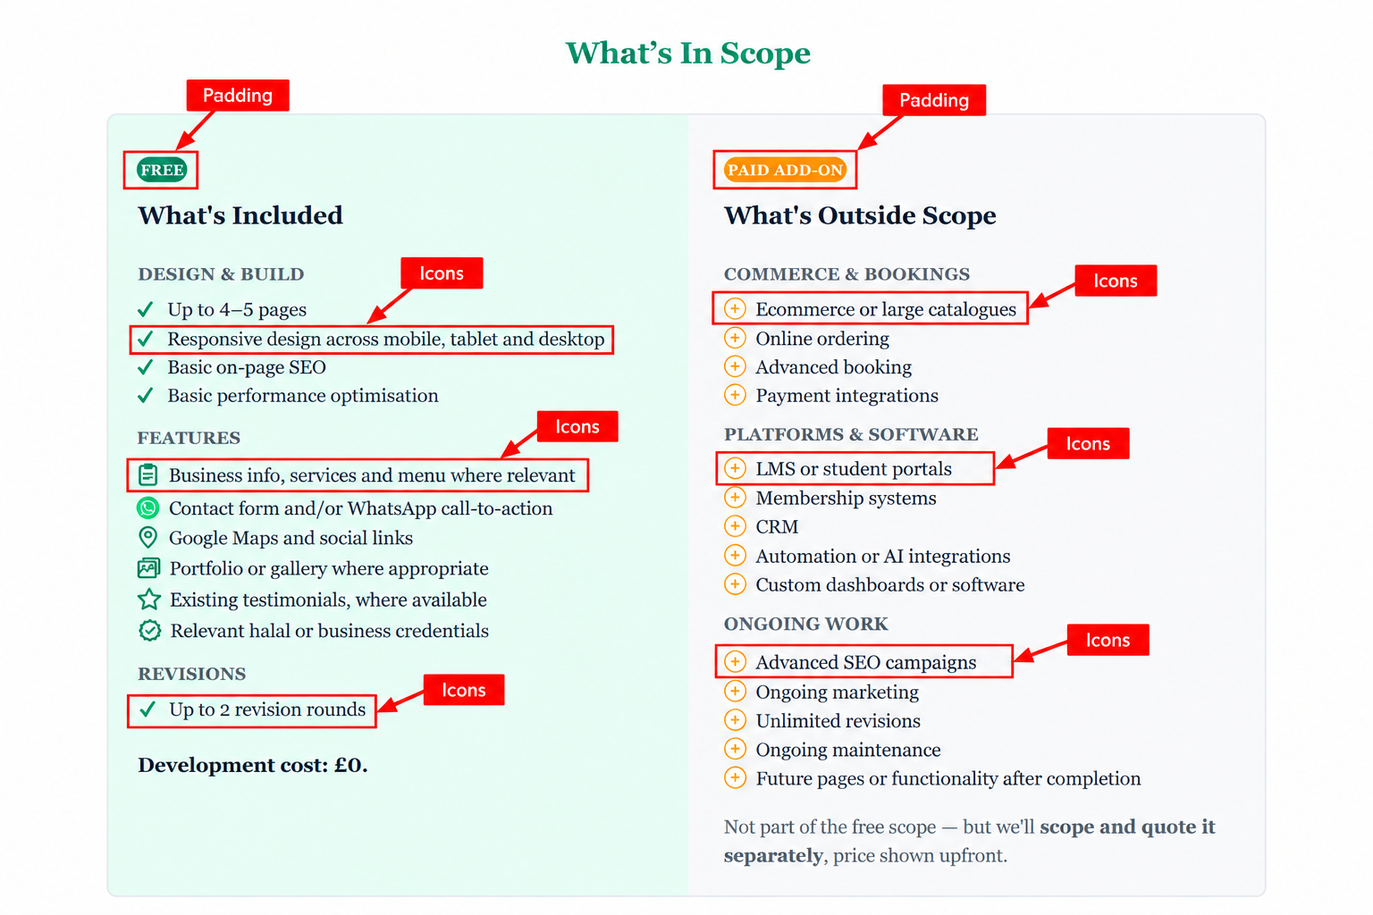
Issue: Icon styles, sizes and alignment are inconsistent; the FREE and PAID ADD-ON badges also feel cramped.
Fix: Use one consistent icon system with uniform size/alignment, and increase the internal padding of both badges.
Takween Connect – Landing Page Review
7. Qualification CTA
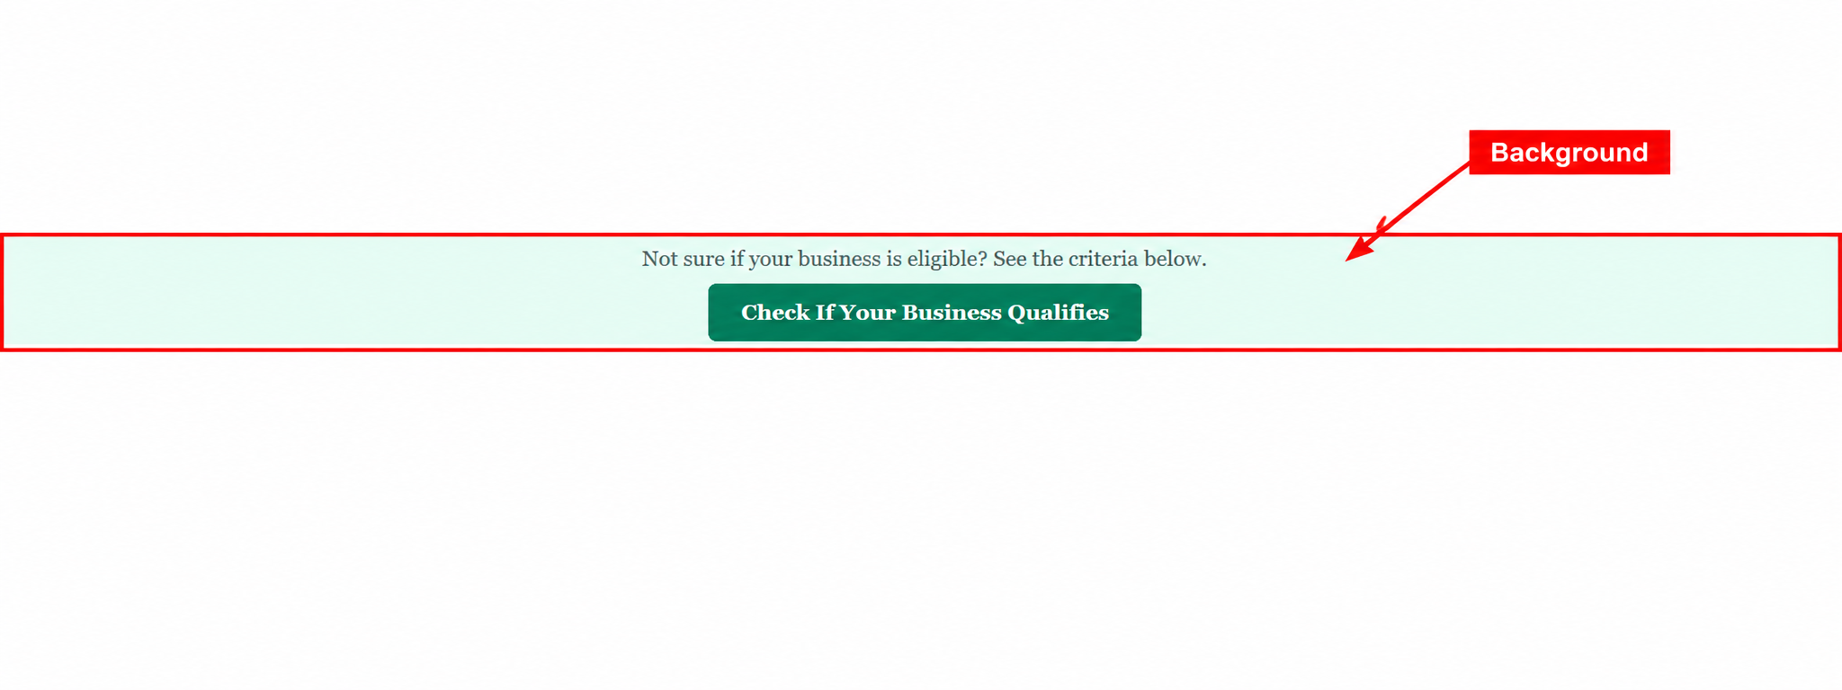
Issue: The coloured background strip behind the text and CTA feels unnecessary and visually disconnected.
Fix: Remove the separate background band and place the text/button on the normal page background with clean spacing.
8. Final CTA
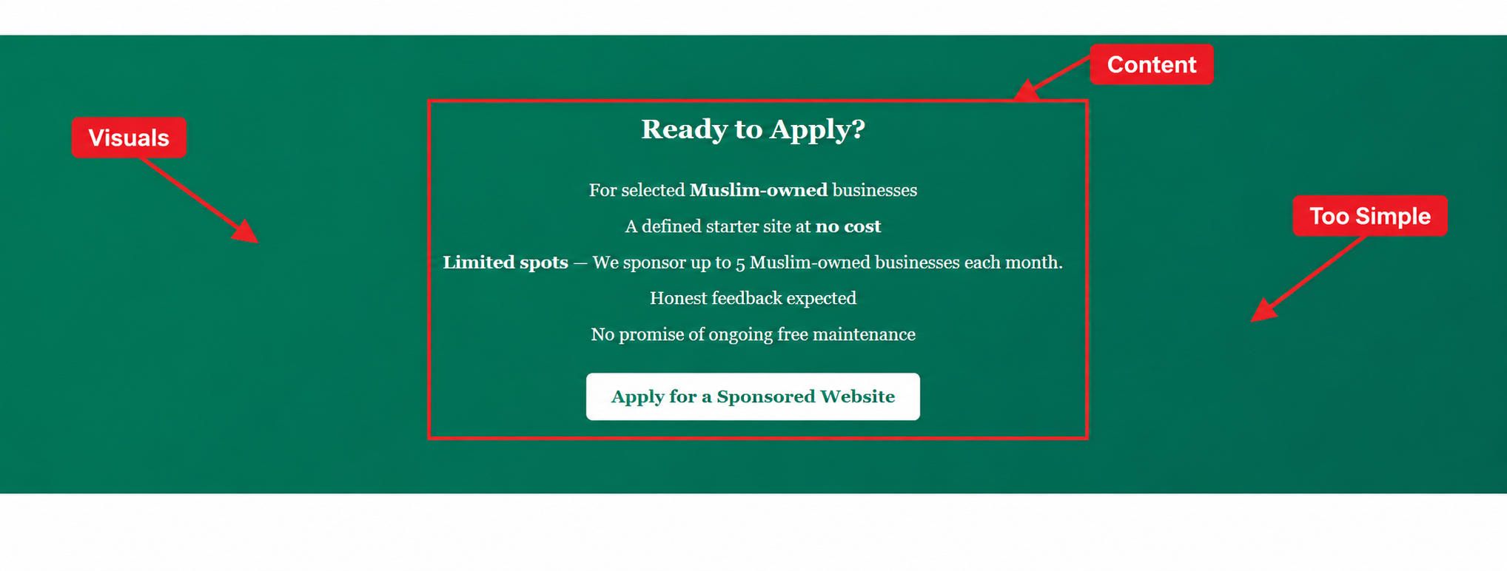
Issue: The final section relies only on centred text and feels too simple for an important conversion point.
Fix: Add a subtle supporting visual or portfolio mockup and improve hierarchy while keeping the CTA as the main focus.
Takween Connect – Landing Page Review

